**NFRF Team iNeuron’s 2025 Annual Symposium: A Celebration of Progress and Collaboration**

This January, Team iNeuron gathered at the beautiful Kingbridge Centre in King City, ON, to mark the successful completion of the second year of our NFRF team project. Surrounded by stunning natural scenery and supported by warm hospitality, the 2025 Annual Symposium was a vibrant celebration of our team’s achievements and a chance to chart the course ahead.

The symposium featured a full schedule of dynamic sessions, scientific presentations, and collaborative discussions. Team members shared exciting new findings, highlighted ongoing research, and exchanged ideas that will shape the next phase of our work together.

In addition to showcasing the impactful science happening across our network, the event included stimulating workshops and sessions that reinforced our shared mission and strengthened our connections as a team. The energy, creativity, and commitment on display throughout the event made it a truly memorable experience.

**Symposium Highlights**

Our 2025 Annual Symposium was filled with engaging sessions, thought-provoking panels, and opportunities for meaningful connection. Here are some of the standout moments:

***ABLE “Get to Know Us” Roundtable***

This interactive session invited ABLE members, trainees, and researchers to share their personal stories and pathways to joining Team iNeuron. It was a heartening moment of connection, helping to strengthen bonds across disciplines and institutions.

***ABLE Team Presentation***

Four members of the ABLE team shared exciting accomplishments from the past year, unveiling newly developed resources including an Infographic, the ABLE Guidebook, and a practical Tipsheet. These tools are designed to support ongoing collaboration and enhance team knowledge-sharing.

***Bioethics Panel***

Moderated by Dr. Ubaka Ogbogu, our expert panel, featuring Dr. Debojyoti Chakraborty, Dr. Mira Puri, Dr. Sowmya Viswanathan, and Dr. John Bell, led a powerful discussion entitled “Accessible and Affordable Advanced Therapies: Contexts, Challenges, and Opportunities”. The panel explored critical issues around equity, cost barriers, and innovation in the rapidly evolving field of advanced therapies.

***Keynote Address: Dr. Ravi Menon***

Dr. Ravi Menon of NFRF TRIDENT (TRanslational Initiative to DE-risk NeuroTherapeutics) delivered an inspiring keynote presentation. He offered insights into TRIDENT’s mission and structured pipeline for neurotherapeutics development, sparking discussions on potential future collaborations between TRIDENT and Team iNeuron.

***Poster Award Winner***

Congratulations to Dr. Jack Hickmott, recipient of a $500 cash prize for his outstanding research presentation. His poster was recognized for its clarity, accessibility, and strong communication using plain language-core values of the ABLE team.

***Flash Talk Presentations***

Our Highly Qualified Personnel (HQP) presented rapid-fire overviews of their research during the Flash Talk sessions. These snapshots piqued curiosity and encouraged deeper engagement with their work during the evening poster session.

**Sponsor Acknowledgement**

Team iNeuron sincerely thanks the following companies for their generous sponsorship of this symposium. Their invaluable support significantly contributed to the success of the event and is truly appreciated.

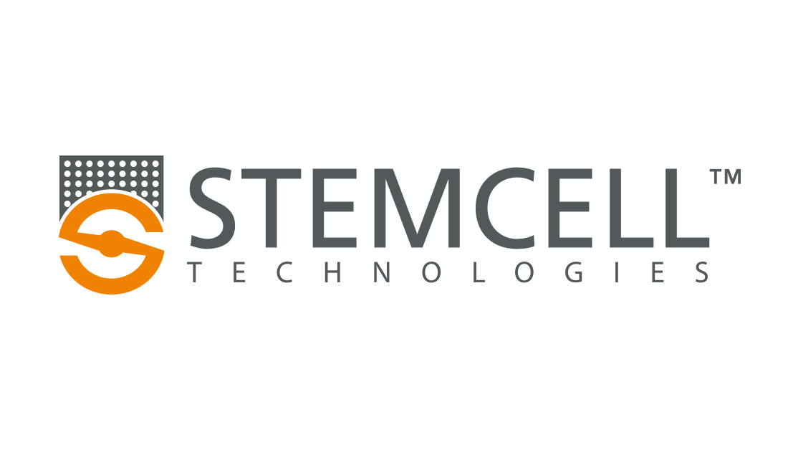

**Stemcell Technologies**

Representative: James Vinnai

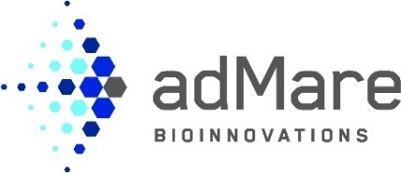

**adMare BioInnovations**

Representative: Daneck Lang-Ouellette